**Pymaceuticals Analysis and Conclusions**

**Objective:**

To analyze the data to show the efficacy of four treatments (Capomulin, Infubinol, Ketapril, and Placebo) in Pymaceutical’s portfolio.

**Method:**

In this study, 250 mice were treated through a variety of drug regimes over the course of 45 days. The mice were distributed randomly into groups of 25 each and their physiological responses were then monitored over the course of time in intervals of 5 days for the drugs in Pymaceuticals portfolio. Results were drawn to compare the efficacy of the 4 drugs i.e Capomulin, Infubinol, Ketapril, and Placebo

**Observations:**

* Survival during Treatment:

In the group of mice receiving Capomulin, 21 of 25 mice survived (84%) vs 11 of 25 mice receiving placebo (45.8%). Capomulin shows the highest survival rate over 45 days of treatment.

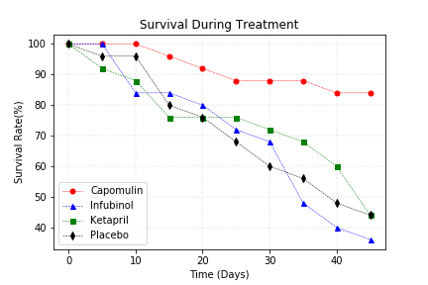

Fig. Survival During Treatment

* Tumor response to treatment:

Of the four treatments of interest (Capomulin, Infubinol, Ketapril, and Placebo), Capomulin is the only treatment under which the tumor volume decreases over 45 days. Mice treated with Capomulin showed 19.48% decrease in tumor volume during the test period.

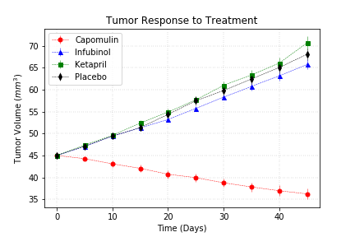

Fig: Tumor volume

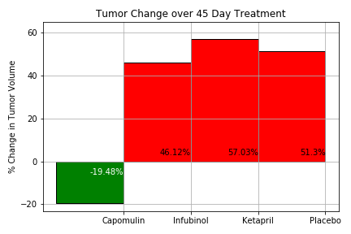

Fig: Change in Tumor Volume

* Metastatic response to treatment:

Over 45 days of treatment, mice treated with Capomulin showed the least increase in the number of metastatic (cancer spreading) sites. 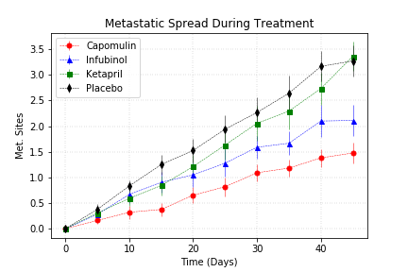

Fig. Metastatic Spread during treatment

Conclusions:

Capomulin is the most effective of the 4 drugs. During the test period, mice treated with Capomulin had the highest survival rate, slow spread of tumor metastatic sites, and overall reduction in reduction in tumor volume.